

**What is the phonics screening check?**

The phonics screening check is a quick and easy way to check children’s phonic knowledge. It helps schools to decide whether children have met the required standard. The check takes place in June for all Year 1 children and any Year 2 children who did not meet the required standard Year 1.

The check contains a mix of real and ‘non-words’ (or nonsense words). The non-words are words that the children have never seen before and help to check that children are using their phonics and have not just memorised the word.

At the end of the school year you will be informed whether your child met the required standard. Teachers will be able to advise you on the next steps for your child.

**What is phonics?**

Phonics is a way of teaching children to read skilfully and quickly. Children are taught how to:

* Recognise the sounds that individual letters and groups of letters make
* Blend these sounds together from left to right when reading a word
* Use this knowledge when writing words

**Phonics**

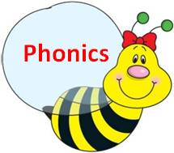

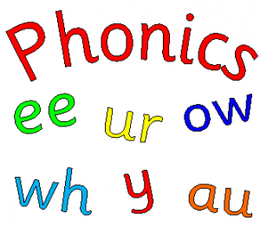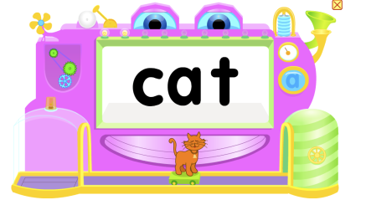

**How can I help at home?**

Phonics works best when children are encouraged and when they enjoy words and books. Parents and carers play a very important part in this.

* Speak to your child about the sounds (phonemes) that they have been learning in school. Then ‘hunt’ for this phoneme in books.
* Encourage children to ‘sound out’ rather than just telling them the word. If the child is struggling you can demonstrate e.g sh-ou-t shout
* Share books and stories together as part of daily routines, in a relaxed and calm way.
* Play word games
* Read words together in supermarkets, road signs etc
* Note down any strengths or difficulties in the Home reading diary – keep the communication between yourself and the teachers open.

**What if I am not confident enough to help my child?**

There are many websites and apps available which will help both you and your child. Try some of these:

<http://www.phonicsplay.co.uk/>

<http://www.bbc.co.uk/bitesize/ks1/literacy/phonics/play/>

<http://www.letters-and-sounds.com/>

Be careful not to use Americanised sites as the pronunciation of the sounds can be very different and can confuse children.